02-05 Sub-section: Pulse of the Bay
Main Message
Scientists are monitoring the health of the Bay, and tracking its changes.

02-05.01 Component: monitoring Native and Invasive species

Main Message
Scientists take samples and count the numbers of different native and invasive species in the Bay. Over time, they can see if particular species are increasing or decreasing, or if new species have been introduced.

Visitor Objectives / intent
Description / walk through
Key Elements

Key Monitoring Organization: California Department of Fish and Wildlife
Contact: Max Fish, Kathy Heib

Objects:
        - “faked” field sheets showing species counts
        - trawl net with doors (size?)
        - rulers?
        - video. They go out the first two weeks of every month. We need to arrange.

Possible activity:
        - Matching species? Guessing which are native and which exotic?

Next step:
- Decide if we want a video or not.
- Contact Cal Fish and Wildlife. Confirm size of trawl net; discuss other possible loans. Possible other source of loan of equiptment is David Bell, Romberg Tiburon Center.
- Develop activity

Notes:
http://www.dfg.ca.gov/delta/projects.asp?ProjectID=FMWT
The Fall Midwater Trawl Survey (FMWT) ) has sampled annually since it's inception in 1967, with the exceptions of 1974 and 1979, when sampling was not conducted. The midwater trawl net has mouth dimensions of 12 ft x 12 ft when stretched taught, but mouth dimensions will be smaller when under tension during a tow. Net mesh sizes graduate in nine sections from 8-inch stretch-mesh at the mouth to 0.5-inch stretch-mesh at the cod-end. All four corners of the net mouth are connected to planing doors, which together counteract the drag on net material and hold the net mouth open when being towed through the water. At each station a 12 minute tow is conducted during which the net is retrieved obliquely through the water column from bottom to surface. All fish, shrimp, and jellyfish are identified and enumerated. In addition, the crew measures water temperature, electrical conductivity (specific conductance), Secchi depth, and turbidity.
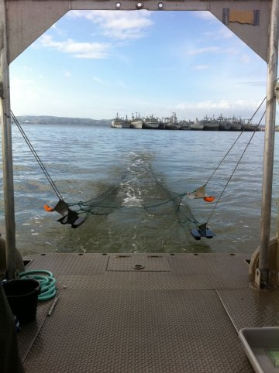

http://www.dfg.ca.gov/delta/ProjectDescription.asp?ProjectID=BAYSTUDY
The San Francisco Bay Study (Bay Study) was established in 1980 to determine the effects of freshwater outflow on the abundance and distribution of fish and mobile crustaceans in the San Francisco Estuary, primarily downstream of the Sacramento-San Joaquin Delta. The Bay Study uses a 42-foot stern trawler to sample with 2 trawl nets at each open water station. The otter trawl, which samples demersal fishes, shrimp, and crabs, is towed against the current at a standard engine rpm for 5 minutes then retrieved. The midwater trawl, which samples pelagic fishes, is towed with the current at a standard engine rpm for 12 minutes and retrieved obliquely such that all depths are sampled equally. Fish, caridean shrimp, and brachyuran crabs are identified, measured, and counted. Shrimp and crabs are also sexed. Sampling effort is quantified (i.e. distance towed, volume of water filtered) and salinity, water temperature, Secchi depth, and station depth are measured; wave height, tide, cloud cover, and tow direction are categorized. The length, catch, and effort data is used to calculate catch-per-unit-effort (CPUE) by species and age class. The CPUE data is used to calculate monthly and annual abundance indices, which are used to track seasonal and annual population trends. Important factors that control or regulate abundance and distribution of fish and mobile crustaceans in the estuary include salinity, temperature, freshwater outflow, ocean temperature, upwelling, and surface currents, primary and secondary productivity, and introduced species. We are interested in how species respond to changes in the physical environment on several temporal scales – seasonal, annual, decadal, and longer..

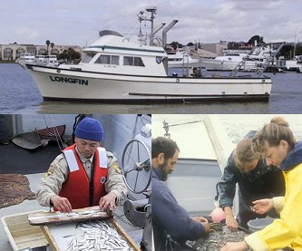

02-05.02 Component: monitoring contaminants through bivalves

Main Message
Scientists can monitor how much pollution is in the Bay by measuring how much of it is picked up by clams, oysters, and mussels.

Visitor Objectives / intent
Description / walk through
Key Elements
Key Monitoring Organization: Applied Marine Science
Contact: Paul Salop, Senior Scientist, Principal

Objects:
        - cage and buoys, filled with bivalves?
        - dry suit
        - hydrophone
        - audio. Audio of 2-way communication on hydrophone between divers and those above water on the boat (snippets might include things like “ "at the mooring", "found one cage", "up to elbow in Bay mud", "coming to surface because we can’t find the piling tether")

Possible activity:
        - something that illustrates how a filter works?

Next step:
- Decide if we want audio or not; dry suit and hydrophone or not.
- Contact Cal Fish and Wildlife. Arrange visit to their storage and select artifacts.
- Develop activity

Notes:
The natural water filtration system of bivalves leads them to absorb contaminants humans add to the water. Scientists regularly test bivalves for chemicals like PCBs, mercury, and new emerging contaminants like PBDEs--the levels of pollutants in the bivalves’ tissue are often quite high. It is important to note, however, that bivalves do not permanently remove contaminants from the environment—these chemicals are often still passed on to larger organisms that feed on clams or return to water and sediment when the clam dies and its tissues decompose.

The San Francisco Estuary Regional Monitoring Program for Trace Substances (RMP) has been analyzing bivalve tissue samples for trace contaminants since 1993. Bivalves bioaccumulate chemical contaminants through their food, by ingesting sediment and assimilating contaminants that are sorbed to particles, and by filtering dissolved contaminants directly from the water column. Bivalves are excellent organisms for biomonitoring of contaminants since they accumulate contaminants from the ambient environment, have limited mobility and are fairly resistant to contaminant effects.

Bivalves are deployed at a total of 9 fixed mooring stations within the Estuary for a period of 90-100 days. Bivalve cages must be found by divers with almost zero visibility since there is so much suspended sediment in the water.

Samples were analyzed for synthetic trace organics, which included PAH, PCBs,
pesticides, polybrominated diphenyl ethers (PBDEs), nitro and polycyclic musks,
phthalates, p-nonylphenol and triphenylphosphate. Contaminant concentrations in tissue of transplanted bivalves were measured before deployment (T-0 or background concentrations) and at the end of the 90-100 day deployment period.

http://www.amarine.com/node/37
Regional Monitoring Program for Water Quality in the San Francisco Estuary. AMS has been instrumental in the design and management of this multi-million dollar annual program for the San Francisco Estuary Institute (SFEI) and the San Francisco Regional Water Quality Control Board since its inception in 1993.

The program requires sampling water and sediments for trace elements, trace organic chemicals, and toxicity.

It also includes a bioaccumulation-monitoring element in which transplanted mussels and resident clams are collected and analyzed for various chemical constituents. At this time, AMS supports program design, field program management, sample collection and quality assurance, and data management services. AMS personnel also participate on several technical work groups that help manage the direction of the RMP.

02-05.03 monitoring benthic ecosystem (bay mud) at water treatment outfalls

Main Message
Scientists look at the animals growing on the bottom of the bay around the outfall of waste water treatment plants to make sure pollution is not entering the bay from the treated water.

Visitor Objectives / intent
Description / walk through

Key Elements
Key Monitoring Organization: San Francisco Public Utilities Commission
Contact: Michael Kellogg

Objects:
        - Fish and crab specimens (must be returned)
        - Archived specimens, must be returned and not used
        - specimens for microscope viewing: various polychaetes, various mollusks, various crustacea. (need to be returned in same condition?)

Possible activity:
        - video microscope, identification of species

Next step:
- Confirm that we can have items that could be used up and not returned. If not, then figure out how to create an activity that will not damage the specimens
- Contact SFPUC. Aquarium of the Bay may also be a source of specimens
- Develop activity

Notes:
As part of the City's National Pollutant Elimination Systems (NPDES) permit requirements, benthic samples are collected from San Francisco Bay and the Pacific Ocean. City biologists identify organisms to the species level. Marine benthic sample sorting and invertebrate taxonomy services are needed to evaluate potential environmental impacts associated with the discharge of treated wastewater. Degradation is determined by comparison of the waste field and reference site(s) for characteristic species diversity, population density, contamination, growth anomalies, debility, or supplanting of normal species by undesirable plant and animal species. Southeast (near Heron’s Head) and Oceanside Water Pollution Control Plants are monitored by SFPUC.

Other objects / monitoring equipment:
- Niskin bottle?

Applied Marine Science
        - They have CTD instrument (measuring connectivity, temperature and depth) but may need it during the course of the exhibit, and it would be an artifact loan.
        - They have a sediment grab, but may be too dangerous / fragile
Sediment grab:
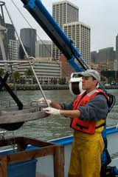

Romberg Tiburon Center (David Bell)
- They “may have some older monitoring equiptment”

Other exhibit ideas:

• Collage of the 250 identifiable harbor porpoises that forage in the Bay (including the white porpoise); matching activity?

• Clear plexiglass tube filled with water and sediment that you can shake. Measure suspended sediment concentration with secchi disk or turbidity meter.
